Assignment 5 (Parallel Sorting)

Name: Parth Vasant Kataria

NUID: 002964611

Part 1 – Code

Array Size – 1 million, 2 million, 3 million

Threads – 2 to 32 (powers of 2)

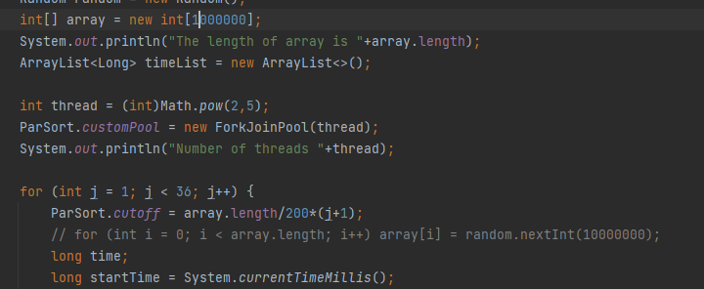

Part – 2 Observations



Part – 3 Graph

Few Example

Thread- 2

Good Cut-off: 50% of the array size

Thread – 4

Good Cut-off: 25% of the array size

Part 4 Conclusion

The performance is similar when the number of threads is increased.

Good Cut-off – array size/no. of threads